

**Deconstruction**

Speech given by

Ben Broadbent, External Member of the Monetary Policy Committee, Bank of England

Lancaster University Management School 29 October 2012

I would like to thank Alina Barnett and Adrian Chiu for research assistance and I am also grateful for helpful comments from other colleagues. The views expressed are my own and do not necessarily reflect those of the Bank of England or other members of the Monetary Policy Committee.

All speeches are available online at [www.bankofengland.co.uk/publications/Pages/speeches/default.aspx](http://www.bankofengland.co.uk/publications/Pages/speeches/default.aspx)

# Introduction: a bust without a boom

Economies are cyclical. Either side of recessions they tend to go through periods of relatively strong growth. But one notable thing about the 2008/09 downturn is not just that it hasn’t been followed by much of an expansion – of that we are all painfully aware – but that it wasn’t preceded by a much of a boom either. As the Governor pointed out in a speech1 earlier this month, GDP grew only in line with its post-war trend in the run-up to the recession. Scaled by the working-age population, growth was actually slightly below that average. For each of the past three cycles Chart 1 plots cumulative changes in per capita GDP from a point four years before the peak.

If these trends are noticeable for the aggregate economy, they are that much more striking for the construction industry. According to current ONS estimates construction output has shrunk by 11% over the past year, knocking around 0.8% from whole-economy GDP. Four years on it is 18% lower than at the last cyclical peak, worse than after either of the previous two recessions (Chart 2). Yet, and in contrast to those earlier cycles – especially that of the late 1980s – this slump has come not after a period of strong growth but one with no growth at all.

# Chart 1: Latest cycle: shallower expansion, deeper downturn

**Chart 2: Particularly true of construction sector**

130

**Index, output 4 years**

**from peak = 100**

1980s recession

1990s recession 2008/09 recession

**Years from peak**

125

120

130

120



**Index, construction**

**GVA 4 years from peak = 100**

1980s recession

1990s recession

2008/09 recession

**Years from peak**

115

110

110

105 100

‐4 ‐3 ‐2 ‐1 0 +1 +2 +3 +4

Source: ONS

100

95

90

85

80

90

80

70

‐4 ‐3 ‐2 ‐1 0 +1 +2 +3 +4

Source: ONS

In this speech I want to try and understand why that occurred – why, in the construction sector more than any other, we’ve experienced a bust without any sort of preceding boom – and what it might mean for growth from here.

1 “Twenty years of inflation targeting”, Stamp Memorial Lecture, London School of Economics. 9 October 2012. [www.bankofengland.co.uk/publications/Documents/speeches/2012/speech606.pdf](http://www.bankofengland.co.uk/publications/Documents/speeches/2012/speech606.pdf)

One factor, I will suggest, relates to a point I made earlier this year about the origins of UK banks’ losses. Because these occurred mainly on their large overseas balance sheets, the resulting tightening of credit has been greater than would have been caused by domestic factors – including prior growth of debt-financed spending – alone.

Another is that, for a long while before the crisis, the construction industry saw no growth in productivity. Its relative costs and prices therefore rose rapidly and, although nominal spending on construction grew fairly strongly, the sector’s real output did not.

I’ll begin by putting the drop in construction output into some sort of context, relative to the past and those in other countries. The following section puts forward some explanations for the “boomless bust” in construction, and explains why we should expect it to come to an end soon. The conclusion makes some wider (and vaguely related) points about targets for monetary policy.

# Investment, construction highly cyclical: downturns are usually big

One thing that does not account for the scale of the slump since 2008 is public-sector spending. It’s true that public-sector investment grew strongly during the recession itself and – in line with the plans formulated by the last government and matched by the current administration – has since fallen back again (Chart 3).

There’s a similar profile in the equivalent parts of the construction data, in green. But public-sector investment is still slightly higher than it was on the eve of the crisis and it accounts for only a quarter of sectoral demand anyway. The contraction since 2008 has instead been driven by a collapse in private-sector demand (Chart 4).

# Chart 3: Output on public-sector construction projects mirrors investment profile

Real public sector GFCF (LHS)

Real public sector constr. orders & maintenance spending (RHS)

# Chart 4: Private sector key driver of downturn

15

**Annualised**

**£bn, 2005 prices**

Change in public sector constr. output

Change in privatesector constr. output

80 43



**£bn**

**£bn**

70 39

60 35

50 31

40 27

30 23

20 19

10 15

10

5

0

‐5

‐10

‐15

‐20

‐25

‐30

0

90 95 00 05 10 15

11

2008 2009 2010 2011 2012

‐35

Source: HMT Source: ONS

In and of itself, this isn’t that surprising. Because they provide security, buildings are a natural home (no pun intended) for debt finance. Over 90% of the stock of UK non-financial-sector debt is secured on property and new building accounts for a disproportionate share of debt-financed spending. So a downturn driven by a contraction in credit supply was always likely to hit the construction sector particularly hard. Chart 5 plots the RICS survey balance for New Buyer Enquiries – which one can think of as a measure of the desire to move house, and the associated demand for new mortgage debt – against actual rates of turnover in the housing market. I view the breakdown of the relationship between the two as a clear sign that, since 2008, it is the supply not the demand for mortgage debt that is driving activity in the housing market. Note that, as well as being well correlated with each other, mortgage approvals and market turnover are also correlated with spending on new capacity (Chart 6).

# Chart 5: Housing market activity no longer demand driven

**Net balance**

60

RICS New Buyers' Enquiry eight months

earlier (LHS)

HMRC Housing Transactions (RHS)

40

20

0

‐20

‐40

‐60

2001 2003 2005 2007 2009 2011

**000's**

185

160

135

110

85

60

35

# Chart 6: Mortgage approvals and housing turnover correlated with spending on new capacity

7 9

**% GDP**

**Per 100**

**dwellings, annualised**

Housing transactions (RHS)

Loans approvals for housepurchase(RHS) Privatesector dwellings investment (LHS)

8

6 7

6

5

5

4

4

3

3 2

1

2 0

1992 1997 2002 2007 2012

Source: HMRC and RICS Source: ONS, HMRC and Bank of England

Even without this additional effect construction is always highly cyclical. It tends to experience deeper contractions that other sectors during every recession, whatever its origins. The reason is that the flow of new investment, particularly in durable assets, is much smaller than the stock2. So small changes in desired capacity require large adjustments in investment. In booms you have to work hard to add to capacity, and investment tends to rise rapidly. In downturns, when cash-flow is under pressure, you can afford to slash the rate of addition to capital without having an immediate or significant impact on the stock. Charts 7a and 7b display standard deviations of annual growth rates, for various parts of expenditure and output, in post-war UK data.

2 In steady state the investment: capital ratio equals the rate of depreciation plus the underlying rate of growth. According to national accounts estimates, non-building capital depreciates, on average, at around 15% a year. For buildings, the rate is only 2.5%. So in steady state, assuming trend growth of 2.5%, the stock of buildings will be around 20 times the rate of gross investment (1/(2.5% + 2.5%)) compared with a ratio of 6 for other forms of capital.

# Chart 7a: Investment, especially in more durable assets, more variable than consumption

10

Standard deviation

of annual growth

9

8

7

6

5

4

3

2

1

0

# Chart 7b: Similar ranking on output side of economy

10

Standard deviation

of annual growth

9

8

7

6

5

4

3

2

1

0

Dwellings investment

Other investment in

buildings

Other investment

Consumption

Housing construction

Other construction

Other capital goods production

Other economy

Source: ONS Source: ONS

# But puzzling after no boom

But this point makes it harder to see busts in construction except in the context of preceding booms. Typically, one of the reasons the private sector wants to cut back on new investment in buildings in a downturn is precisely that it has

over-built capacity during the upswing. It is the boom itself that, in part, sows the seeds for the bust. We’ve already observed how much stronger were earlier expansions in aggregate construction activity. The comparisons for private-sector demand specifically are that much starker (Chart 8).

# Chart 8: Stark contrast in profile of private-sector demand for construction compared with earlier cycles

105

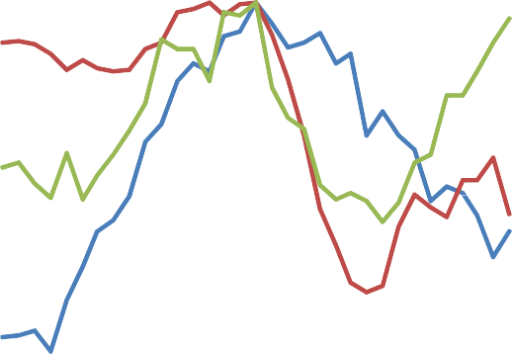

**Peak=100**

**2004‐12**

**1975‐83**

**1986‐94**

**Years from peak**

100

95

90

85

80

75

70

65

60

‐4 ‐3 ‐2 ‐1 0 +1 +2 +3 +4

Source: ONS

The latest cycle in the UK also stands out relative to other countries. Chart 9 shows that, at least among the major developed economies it was generally those with the biggest booms in construction, prior to the crisis, that have since experienced the biggest busts. The UK is also an outlier in the cross-country comparison of (pre-crisis) growth in construction output and real house prices (Chart 10).

# Chart 9: Countries with construction busts have generally had construction booms

4



Switzerland

Germany

Austria

France

UK

Holland

Italy

Denmark

Spain

# Chart 10: Like others, UK saw strong growth of house prices but, unlike others, no construction boom

25



**Real**

**construction growth (%)**

Spain

**Real house price**

**growth (%)**

UK

Germany

2

20

**Bust, annualised growth rate (%)**

0

15

‐2

10

‐4

‐6

‐8

‐10

‐1 0 1 2 3 4 5

**Boom, annualised growth rate (%)**

5

0

‐5

‐10 0 10 20 30 40 50

Source: Eurostat, OECD and Bank of England calculation Source: Eurostat, OECD, Federal Reserve and Bank of England

calculation

So we return to the original question: why was the bust so big when there hadn’t been much of a boom? I’ll briefly outline three things that I think matter, two financial and one “real”. I’ll then discuss whether any of that has implications for construction growth over the future.

# Chart 11: Loans to commercial property companies more than doubled relative to GDP

**% GDP**

45

Lending to commercial real estate Non-CRE bank lending

40

35

30

25

20

15

10

5

0

1987 1990 1993 1996 1999 2002 2005 2008 2011

Source: ONS

The first point to make is that additions to physical capacity aren’t the only way in which booms can create their own busts: financial leverage can do the same. And there was certainly plenty of that going on ahead of the crisis. Loans to commercial property companies more than doubled relative to GDP (Chart 11). Mortgage debt also rose strongly.

As I explained in a speech in March3, only a part of this was used finance extra spending (still less consumption in particular). Most was just one side of a transfer of financial resources from buyers of property to sellers, with the latter group accumulating equivalent amounts of cash.

3 “Deleveraging”, Market New International, available at <http://www.bankofengland.co.uk/publications/Documents/speeches/2012/speech553.pdf>

But that doesn’t mean the process was riskless, as the debt and the cash ended up with different people. So even if it wasn’t adding much to physical capacity, increased leverage was adding to the economy’s vulnerability to economic shocks.

Second – and this is again something I discussed in more detail in March – the credit shock that then ensued wasn’t just the result of domestic problems. In what has been a global crisis, it owed a great deal to the rapid growth – in size and in risk – of UK banks’ overseas assets. That’s where most (three-quarters) of their losses have occurred. And because banks then came under pressure to shrink balance sheets everywhere, at home as well as abroad, these foreign losses added to the contraction in domestic credit supply. Thanks to the international exposure of its banks the UK has been, in some sense, a “net importer” of the financial crisis.

Third, low productivity growth in the construction sector meant that any extra money that did go on new projects – and in some areas there was quite a bit of it – went not into real output but higher prices. Like Chart 8, Chart 12 shows the output of the construction sector on private-sector projects over the last two cycles. But instead of real activity – the actual rate of addition to physical capacity – it plots nominal output divided by prices in the economy as a whole (the GDP deflator).

# Chart 12: Differences in cash spending on construction smaller

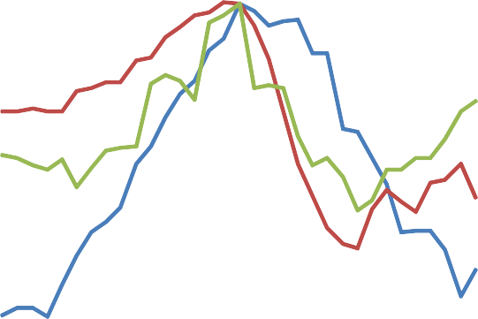

**Peak=100**

**2004‐12**

**1975‐83**

**1986‐94**

**Years from peak**

‐4 ‐3 ‐2 ‐1 0 +1 +2 +3 +4

105

100

95

90

85

80

75

70

65

60

55

50

# Chart 13: Rise in real construction prices in pre-crisis decade due to relatively low productivity growth

1.4

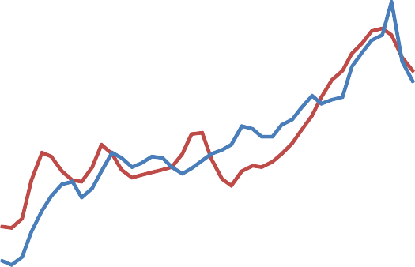

Real construction output deflator (RHS)

Relativeconstruction labour productivity (LHS)

1.3

1.2

1.1

1

0.9

0.8

0.7

0.6

0.5

0.4

1970 1975 1980 1985 1990 1995 2000 2005 2010

1.2

1.1

1

0.9

0.8

0.7

0.6

0.5

0.4

0.3

Source: ONS Note: Real construction deflator = price deflator for construction GVA / overall consumption deflator;

Relative construction labour productivity = Total economy labour productivity / Labour productivity in the construction industry.

Source: ONS

The two cycles still look different. In cash as well as real terms, there was much less of a boom than in the late 1980s. But the difference is smaller. The reason is that, unlike in the 1980s, building costs in the last

decade rose much faster than the general rate of inflation. And the reason for that, in turn, is that relative productivity growth was much lower (Chart 13). During the 1980s, and for much of the 1990s, per-capita output in the construction industry rose by 2% a year. In the decade leading up to the financial crisis, the average was -0.3%.

It’s not clear, to me at any rate, why this occurred. Data from other countries suggests that productivity has, on the whole, grown more slowly in construction than in other parts of the economy. So it’s unlikely ever to be see very rapid growth, over long periods of time, in this country either. But there’s also some evidence that the level of productivity is relatively low in the UK4 (Chart 14) in which case there is room for further growth. Whatever the reason, low productivity growth meant that, even in areas where cash spending grew relatively strongly, it did not result in faster additions to actual capacity.

# Chart 14: Level of UK construction productivity in construction relatively low

$000/head (2005 PPP)

70

60

# Chart 15: Real vs. nominal dwellings investment

6

**% GDP**

Nominal dwellings investment Real dwellings investment

5

50

40 4

30

20 3

10

0 2

AT NL AU FR SP IR FI NW US LX SK IT SD SL KO DE DN NZ IS UK JP PL CZ MX ET PT HU

1985 1990 1995 2000 2005 2010

Source: OECD Source: ONS

One area in which you can see this is housing investment (Chart 15). In cash terms, and relative to the general rate of inflation at the time, growth in the 2004-2008 period was almost as strong as it had been twenty years earlier and peaked at a slightly higher level. But growth in real investment was much slower. And, despite higher nominal spending (as a share of national income) the peak number of housing completions was lower.

4 A government-commissioned report in 2003 (“Rethinking Construction”) found that, while “the industry at its best is excellent...there is a deep concern that the industry as a whole is under-achieving. It has low profitability and invests too little in capital, R&D and training”.

# Prospects for the future

Forecasting is difficult at the best of times and even for relatively stable economic series. Making specific predictions about investment, at a time of heightened risk aversion and great uncertainty in our trading partners, is probably best avoided.

But let me first pick some low-hanging fruit. One thing we know is that the contraction in capital spending by the public sector is soon to come to an end (Chart 3). Having fallen by £20bn in the past couple of years, annual public-sector investment is set to stabilise from now on, at least in nominal terms. Given the lags involved, recorded output on these projects is likely to decline further over the next few months. But it should level out from next spring.

More tentatively, it’s also likely that productivity growth in the sector will be better than in the run-up to the crisis. In a speech last month5 I pointed out that the financial crisis had brought about an unusual degree of dispersion across UK firms. Some had seen higher demand and prices for their output, and were constrained only by lack of capacity (including, sometimes, skilled labour). Others, somehow able to stay in business despite a long period of sub-par returns, had ample spare capacity and were instead constrained by a lack of demand. Given the precipitous fall in activity in the sector, construction surely falls into the second group.

And it is therefore more likely than it was to be able to meet any increase in spending without a rise in costs.

# Chart 16: Nominal growth of private-sector construction slower but real growth higher than pre-crises.

7

**%**

Nominal Real

6

5

4

Indeed, that’s already been happening. In nominal terms, work on private-sector construction projects has grown by just over 5% a year over the past couple of years, slower than in the 2004-08 period (Chart 16). But output growth has been faster in real terms. The reason is that sectoral productivity growth has improved. Cost and price inflation have therefore fallen.

3

2

1

0

2004H1 ‐ 2008H1

2010H1 ‐ 2012H1

What is harder to say is whether that gentle recovery in private-sector spending will continue. Because investment spending is so volatile, and sensitive to even mild changes in business confidence, it would be foolish to make very firm

Source: ONS

predictions.

5 “Productivity and the Allocation of Resources”, Durham Business School, available at <http://www.bankofengland.co.uk/publications/Documents/speeches/2012/speech599.pdf>

I will make a couple of points, however. First the chances of any recovery would be lower had there been a preceding boom and – for any given level of the demand for space – that much more of it to begin with.

There is clearly still spare capacity. According to data from IPD, a supplier of data on commercial property, vacancy rates in that sector are still higher than in pre-crisis days and real rents are still declining (Chart 17). But both measures have improved slightly since 2009. As for residential property, there was a period when spare capacity was growing – house-building exceeded the rate of household formation from 2003-2007 (Chart 18) – but the opposite is now the case and, real rents are now rising6.

# Chart 17: Real commercial rents still declining though at slower rate

**Chart 18: Spare capacity in housing market is narrowing**

**%**

20



Inflation‐adjusted rental growth (LHS) Voids % Income (RHS)

15

10

5

0

‐5

‐10

**%, inverted**

1

3

5

7

9

11

13

1

0.8

**% Dwellings**

**stock**

Housing completion

Household formation

0.6

0.4

0.2

‐15

1987 1992 1997 2002 2007 2012

Source: IPD and ONS

0

15 1991 1996 2001 2006 2011

Source: ONS

6 Quite how rapidly is hard to say. The rental component of the CPI has risen just over 6% over the past two years; the equivalent part of the consumers’ expenditure deflator is up 15%. Estimates from LSL, a property consultant, are closer to the former (10% over three years); estimates from the National Housing Federation are closer to the latter (13%).

# Chart 19: Banks’ funding costs have declined Chart 20: Banks say mortgage supply is easing

400 40



UK Banks' CDS

c.5yr covered bond 5yr Senior Unsecured

**bps**

*Mansion house IR*

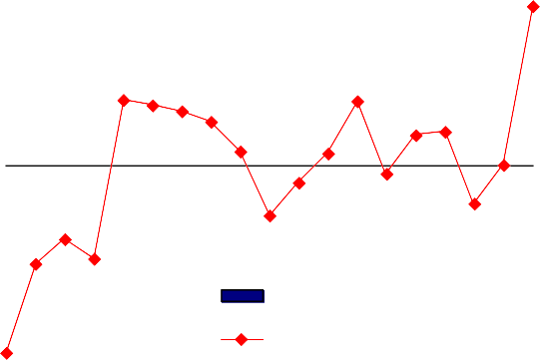

Net percentage balances

Past three months

Next three months

350 30

20

300

10

250 0

Jan 11 Apr 11 Jul 11 Oct 11 Jan 12 Apr 12 Jul 12

200

150

100

50

0

Q2 Q3 Q4 Q1 Q2 Q3 Q4 Q1 Q2 Q3 Q4 Q1 Q2 Q3 Q4 Q1 Q2 Q3

‐10

‐20

‐30

‐40

‐50

‐60

2008

2009

2010

2011

2012

Source: Bank of England Source: Bank of England

Second, and thanks in part to the FLS, banks’ funding conditions have fallen significantly this year

(Chart 19). This holds out the prospect of some easing in domestic credit supply. And although it is too early to expect anything of this sort in the hard data, it is certainly noteworthy that, according to the latest Credit Conditions Survey, the amount of new mortgage credit made available to households increased markedly in the in the last quarter (Chart 20). Given the correlations involved (Chart 6), and if it actually resulted in more mortgage approvals, I would expect this to push up residential investment as well.

# Conclusion: some points about inflation targeting

You can make of all this what you will. The prospects for the construction sector look less unfavourable than they have been for a while. But in what is a volatile sector, and an uncertain environment, this is not the same thing as a hard forecast. That uncertainty makes it less directly important for monetary policy today.

What I do think, however, is that some of the points I’ve made here – that credit conditions are formed internationally, not just domestically, and that underlying productivity growth is not necessarily constant – do have some wider bearing on recent debates about the appropriate targets for monetary policy.

One criticism of inflation targeting is that it meant monetary policy paid too little attention to the build-up of financial risk ahead of the crisis. A more recent claim, made by some, is that it would be better to aim to stabilise nominal income growth rather than inflation per se. That way, the argument goes, debt-to-income ratios could decline at a predictable rate without the need for nominal deleveraging.

I’m not convinced by either. On the first, the evidence suggests to me that both the build-up of risk ahead of the crisis, and the scale of the subsequent bust, were at least as much global as domestic in origin. Tighter UK policy may have deterred some of the increased gearing in property. But with global real interest rates declining through the period, and because capital markets are open, it would only have been some. And because most of their losses occurred on non-UK assets, it wouldn’t have done much to lower the risks facing UK banks or, therefore, the subsequent tightening in domestic credit supply. Like many others, the construction sector was a victim of a global credit crunch, not a local boom beforehand. The creation of the Financial Policy Committee, which is explicitly charged with limiting systemic risks in the financial system, only strengthens this point.

The second is more nuanced. Monetary policy can, in principle, target any nominal quantity (Britain has, in its time, targeted the price of gold, broad money, the currency, inflation and nothing at all). All have had their adherents and no single one dominates every other under all circumstances. That includes the comparison between inflation and nominal income targets, and I’m certainly not going to give an exhaustive list of the pros and cons here.

But it’s worth saying a couple of things. First, nominal income targeting is no panacea. If supply growth were entirely smooth there wouldn’t be much difference between the two policies7. And if underlying productivity is variable – and I believe the evidence suggests that is the case not just for the construction industry over the past forty years but, since the crisis, for the economy as a whole – then there is an unavoidable short-run trade-off between stabilising real growth and stabilising inflation. If policy had been eased even further since 2008, in order to meet a hypothetical target for nominal income, inflation would surely have been further above its (existing) target. Ultimately, this comes down to a judgement as to whether the predictability of aggregate inflation or the predictability of aggregate nominal income is more desirable. As it happens, I do not subscribe to the view that the need to cut domestic debt:income ratios is the major constraint on domestic activity – that was the point I sought to make in a speech in March – and I therefore doubt that, even in these particular circumstances, increasing the price level would make a great deal of difference to real activity. More generally, neither can be proved absolutely superior to the other.

Second, any target would surely lose its value if it can change according to circumstance. The credibility of the current regime may or may not have suffered had inflation been higher in recent years. But it’s hard to believe it wouldn’t have been seriously damaged – for both the new and the old target – had we simply switched horses in mid-course.

Anyhow, the target for the MPC remains inflation (rightly, in my view). And I, and the other members of the Committee, will continue to set policy in order to meet it.

7 The remaining difference would involve variations in the gap between the GDP deflator and the CPI, mainly due to shifts in the terms of trade, e.g. changes in oil prices. Since, in practice, variations in commodity and other volatile tradable prices have been accommodated by inflation-targeting central banks, the two policies would amount to the same thing.